Urban Buzz

in Cardiff

Welcome to Urban Buzz! This short guide shows some of the simple ways you can enhance your outdoor space to benefit pollinators and engage your local community to take action for nature.
Through the Urban Buzz project in Cardiff, communities are establishing, managing and maintaining pollinator-friendly habitats across the city. Their work is vital. In the UK alone, 23 bee and flower-visiting wasp species have become extinct since the 1850s, primarily caused by habitat loss and the introduction of inorganic nitrogen-based fertilizers and pesticide use. Cardiff is home to a myriad of pollinator species, including one of the UK’s rarest bumblebees; the shrill carder bee.
Urban Buzz site leaders, volunteers and local communities are acting for nature to help improve the future of wild pollinator populations by enhancing their urban green spaces. This not only helps to improve wildlife habitats, but also helps to educate and engage individuals with conservation issues whilst empowering them to make a difference.
In Cardiff, Urban Buzz sites are managed by local groups with support from RSPB Cymru, Buglife Cymru and Cardiff Council as part of the Giving Nature a Home in Cardiff project. This project is made possible through funding from the National Lottery Community Fund.

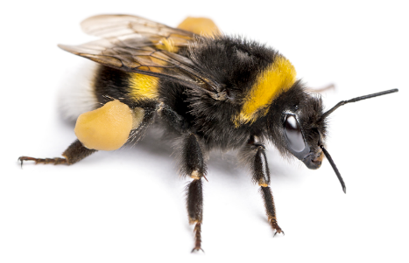

This guide is divided into several section to help you make the most of being an Urban Buzz site:
Pollinators you might spot 3
Workshops 5
Engaging your local community 5
Volunteers 5
Family-friendly volunteering 5
Community events 6
Communications 6
Seasonal newsletter 6
Managing Risk 6
Pollinator surveys 7
Tools and purchasing advice 8
Equipment 8
Buying advice 8
Preventing pests 9
How to create a pollinator-friendly site: step-by-step guides 11
Wildlife lawns 11
Log piles and stumperies 11
Spring-flowering bulbs 12
Shrubs 13
Hardy annual flowering plants 14
Biennial flowering plants 15
Herbaceous perennial plants 16
Flowering trees 17
Bee hotel 18
Bug hotel 19
Climbing plants 19
Herb garden 20
Wildflower meadow 20
Bee bank 21
Pond 22

Pollinators you might spot
Here’s a short introduction to the different groups of pollinators that you might see visiting your Urban Buzz site.

Solitary bees
Unlike bumblebees and honeybees, which are social and live in colonies, solitary bees live solitary lives. Over 250 species of solitary bee are found in Britain. Urban areas can be brilliant places to observe solitary bees, particularly mining bees that nest in underground burrows, and mason and leafcutter bees, that nest in walls, deadwood and other cavities.

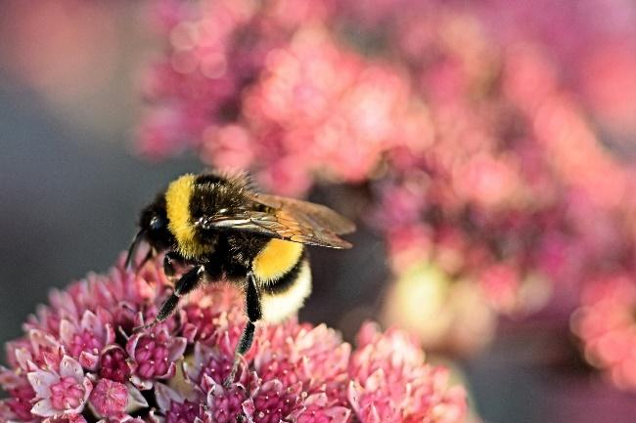
Bumblebees
Being large and furry, bumblebees are instantly recognisable to many and are important pollinators. There are 24 species of bumblebee in Britain, but only 7 (the 'Big 7') are regularly encountered across Britain. These common species are likely to be seen in cities such as Cardiff. Our common bumblebees usually have tails that are either white, red, buff or brown, and some have yellow bands.
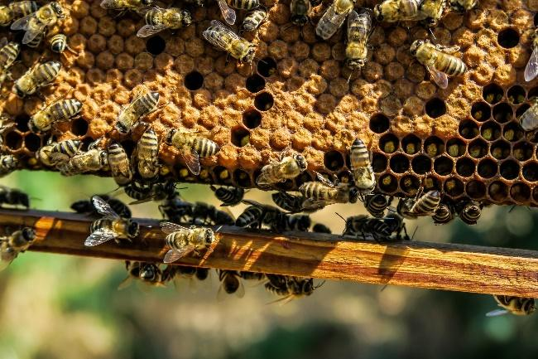
Honeybees
Honeybees vary in colour from all-black to orange banded and are social insects. This means they live together in large, well-organised family groups. Honeybee colonies consist of a single queen, hundreds of male drones and 20,000 to 80,000 female worker bees. Just a single species of honeybee – Apis mellifera – occurs across the whole of Europe.

Wasps
When thinking of wasps, most people envisage yellow and black-banded social wasps that are a nuisance in summer, however there are in fact many different types of wasp. This includes over 250 species of solitary wasp, and a further 6000+ species of parasitic wasp! Wasps come in a variety of colours, shapes and sizes, and although their young feed on animal matter (usually other insects), adults frequently visit flowers to feed on pollen and nectar and can therefore be important pollinators.
Butterflies
Butterflies, with their bright and colourful wings, are considered by many to be the most beautiful and interesting insects. Synonymous with summer, butterflies can be seen visiting flowers in gardens and other urban areas on sunny, still days. Unfortunately, 71% of our butterflies are in long-term decline and are declining more rapidly in urban areas than in the countryside.

Moths
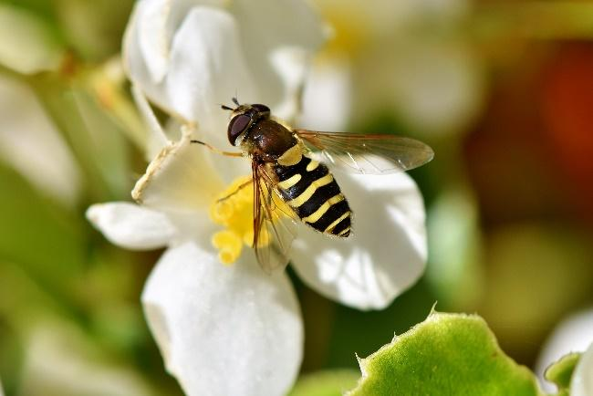
There are around 2,400 species of moth in Britain. At night, moths take over as the premier plant pollinators. Some moths visit flowers to drink nectar and, in doing so, act as pollinators. Some plants are particularly attuned to nocturnal moth pollinators, only producing nectar and scent at night, while others close their flowers during daylight hours. However, not all moths are nocturnal, as some are strictly day-fliers.

Hoverflies and other flies
Hoverflies are important pollinators of flowering plants and can be readily encountered in urban environments. As their common name suggests, hoverflies are often seen hovering close to flowers, displaying extreme agility. They are often excellent mimics of bees and wasps, although they cannot sting. Many other sorts of flies also like to visit flowers, including bee-flies, blowflies and houseflies.
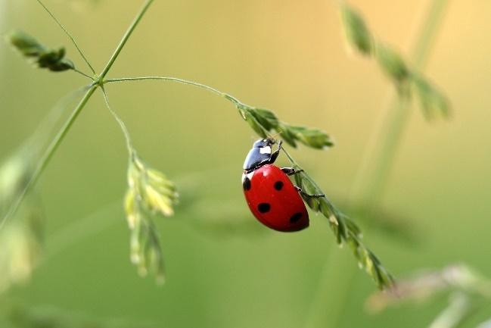
Beetles
Beetles were among the first pollinators to evolve when flowers first appeared some 140 million years ago. Although they are less efficient at pollination than other insects such as bees and flies, beetles still play a role in pollination. There are around 100 pollinating beetle species in Britain and this includes representatives from the soldier, flower, pollen and longhorn beetles.

Workshops
We have developed two, hour-long workshops which we can deliver at your Urban Buzz site to your volunteers and local community in Cardiff to help you improve your sites for pollinators. These are titled ‘Pollinator identification’ and ‘Creating, managing and maintaining pollinator friendly habitats’.
To book your workshops, please email gnahcardiff@rspb.org.uk

Engaging your local community

Volunteers
Volunteers are an essential part of Urban Buzz sites and establishing a regular volunteer group is key to making sure that your site becomes a success for both people and wildlife. If you are new to running outdoor work sessions for volunteers RSPB and Buglife can provide support to develop the skills to manage your site independently and safely.
Running a regular weekly or fortnightly session can be a great way to get local people involved with your site but this will require some planning and leadership from the site leader or lead volunteer(s). Working out who will decide the tasks for each volunteer session is vital to ensuring that tasks are completed; this could be done by the site leader, a regular volunteer or a committee. The Urban Buzz team can work with you to break down your plans into small tasks and advise on the time of year to complete them, however you will need to decide how these fit into your own volunteering calendar.
The Welsh Council for Voluntary Action website has extensive resources and guidance to help you set up and organise your volunteer group. Social Farms and Gardens can also provide support to community growing projects.
Get in touch with gnahcardiff@rspb.org.uk for more advice on recruiting and managing a volunteer group.

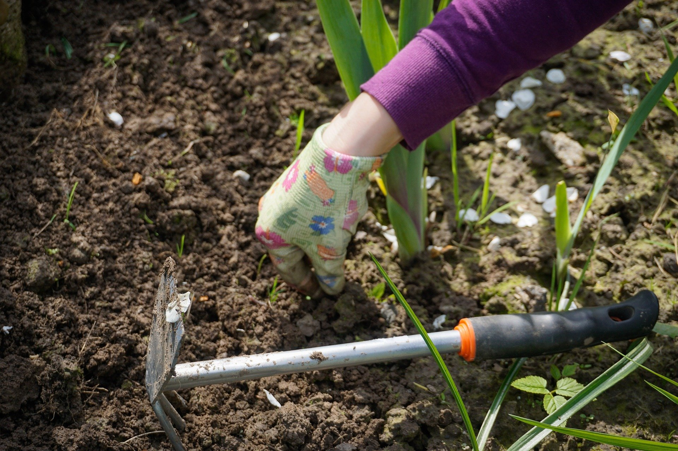
Family-friendly volunteering
Running family-friendly volunteering tasks can be a great way to engage local families with your site. Giving Nature a Home in Cardiff can run family volunteering at your site to help you build connections with local families and hopefully recruit some regular helpers. Contact gnahcardiff@rspb.org.uk if you’re interested in hosting some sessions. We can also advise you about arranging and running your own family volunteering sessions.

Community events
We can also deliver family-friendly events at your site. These events are aimed at connecting children and their families with nature and can include a BioBlitz, Minibeast Hunt, Pond Dipping, seasonal nature spotting and support with family fun days. You bring the audience, and we’ll bring the activities! Email gnahcardiff@rspb.org.uk to book.

Communications
Some sites have set-up their own social media pages to share updates and advertise volunteering sessions. This can be a great way to build up a local following. Use the hashtag #WildCardiff or #CaerdyddGwyllt to help your posts be seen!
There’s also lots of other fun ways to engage people with your activities:
- Create a ‘spotted’ board of the different birds and insects you’ve recently found in the garden and invite others to add to it.
- Ask local children to paint small signs to describe the different areas of the garden.
- Share pictures on social media to show your site blossoming and changing from season to season to help attract visitors and volunteers!
If you find that people using your Urban Buzz site are interested in enhancing their own gardens for wildlife, we can provide free resources and advice. Get in touch and we’ll post you the relevant leaflets and information.

Seasonal newsletter
We have started a quarterly Urban Buzz email newsletter for site leaders and volunteers to keep up-to-date with the latest seasonal gardening tips for pollinators and keep you informed about different activities and events across the Urban Buzz network in Cardiff. If you, or some of your volunteers, would like to receive the newsletter, please let one of the team know via email or email gnahcardiff@rspb.org.uk.

Managing Risk
As you will be working with volunteers and the public you will need to create and implement risk assessments for the activities which will take place on your site. Excellent advice and templates can be found on the Health and Safety Executive website (http://www.hse.gov.uk/). The Social Farms and Gardens’ Community Growing Resource Pack for Wales also contains helpful information on insurance and risk management to get you started.
If your session is being led by one of the Giving Nature a Home in Cardiff team, then we will create and share our risk assessment for that activity with you.

Pollinator surveys

The Urban Buzz project is working with communities across Cardiff to establish, manage and maintain pollinator-friendly habitats to help improve the future of wild pollinator populations, which are currently declining. A greater understanding of these populations is key to determining their health and judging the success of our efforts on Urban Buzz sites.
All Urban Buzz sites are asked to conduct a simple Flower-Insect Timed Count (FIT Count). A FIT Count is a standardised survey coordinated by the UK Pollinator Monitoring Scheme (PoMS) and is designed to gather evidence on the health of our pollinators to inform research and conservation activities.
FIT Counts involve counting all the insects that visit a patch of flowers in a ten-minute period and identifying the insects to broad group level (e.g. beetles, bumblebees, hoverflies). Counts can be made at any location where there are flowers, and whenever the weather is suitable from April to September. FIT Counts need to be completed at least 3 times during this period, which can either be completed by a group or individual in your Urban Buzz team or a member of the Giving Nature a Home in Cardiff volunteer team. Each year, we’ll be in touch in April/May for more information about this. Further information can be found by visiting the UK Pollinator Monitoring Scheme homepage.

Tools and purchasing advice

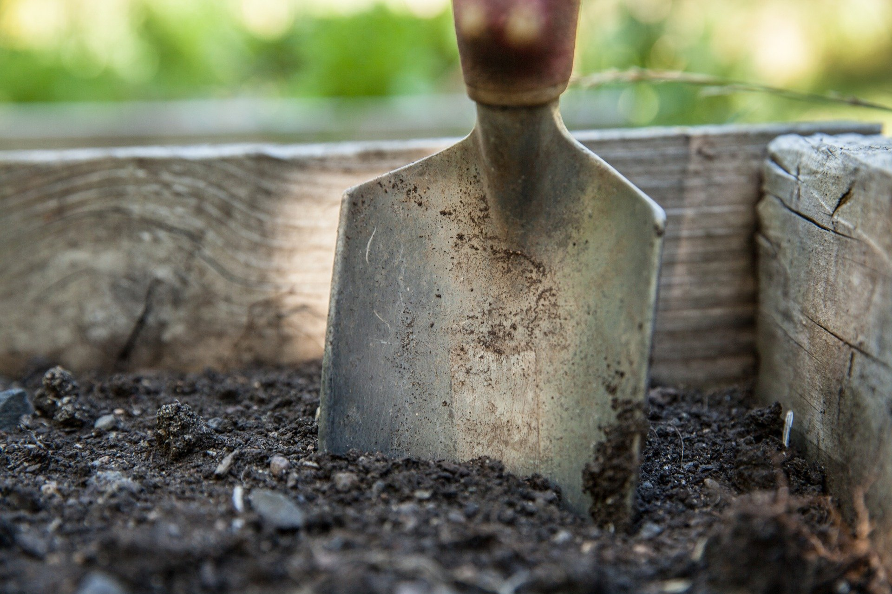
Equipment
To complete many of the tasks, it would be useful to have the following tools on-site where possible:
- Spades
- Garden forks
- Hand trowels
- Gardening gloves
- Wheelbarrow
- Soil rake
- Lawn rake
- Watering can
For more specialist tools, for a specific activity, the Giving Nature a Home in Cardiff team can assist in sourcing. If you feel that your tools may at be risk from theft or misuse, we would recommend that the tools are stored securely in a lockable shed or cupboard.

Buying advice
Peat-free compost
The large-scale removal of peat from bogs in Britain and Ireland is destroying one of our most precious wildlife habitats. Peat alternatives are available in most garden centres and DIY stores, or you can make your own compost. Different peat alternatives are available for seeds, potting and soil conditioning. We endorse peat-free, organic, multi-purpose compost.

FSC certified timber
The Forest Stewardship Council (FSC) is an international network to promote responsible management of the world’s forests and is easily the most recognised ethical & environmental standard for paper/ wood products. Where possible, the use of reclaimed or recycled timber and wood products is preferable to new material. Reusing reclaimed timber is popular and resourceful but check that it is untreated, as chemicals used in wood treatment are often toxic to wildlife. If it is not possible to use reclaimed or recycled timber, always look for the FSC certification logo before buying new timber.

Trees
Deciduous trees (that lose their leaves in winter) are cheapest and lightest to buy when they are dormant in winter (November to March) as a bare-rooted plant, however they can also be bought in pots. Buying young saplings, also known as whips, is the cheapest and easiest way to make sure a tree becomes established. The Woodland Trust is a good source of native trees.

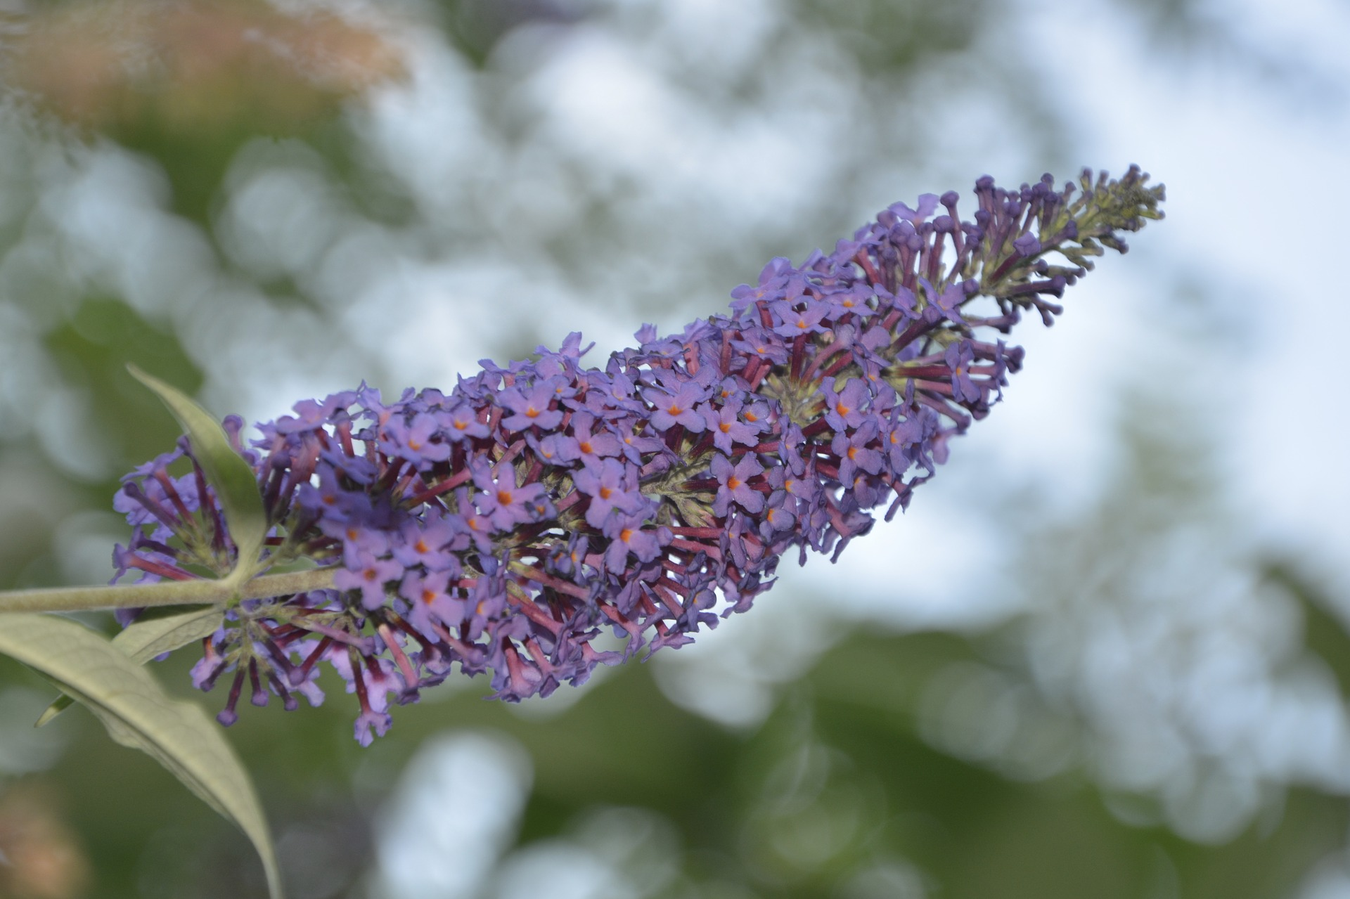
Invasive species
Sites in the UK are home to numerous non-native plants which are much loved by both gardeners and pollinators alike. Unfortunately, a small percentage of these non-native plants are notoriously invasive and are likely to spread uncontrollably and threaten other plants and wildlife. Where possible it’s good to avoid most species of Buddleia, Cotoneaster, Rhododendron, Virginia Creeper and Himalayan Balsam. Some advice on avoiding invasive non-native species is available on the RHS website. This is also a consideration when buying pond plants.

Organic pot plants
Unfortunately, many of the plants and seeds sold in garden centres, even those advertised to be beneficial to pollinators, have been treated with pesticides. This will affect any pollinators that feed on the plant. However, by buying plants which have been grown organically or growing your plants from organic seed you will ensure that your pollinator-friendly plants have not been treated with pesticides.
Many plants for sale are grown abroad and are not biologically screened before being imported. This means that the soil and leaves can sometimes harbour invasive species. By buying British grown plants you can help to prevent invasive species reaching your site and our countryside.

Preventing pests
Chemical control often harms wildlife beyond the targeted species. Many species targeted through chemical control are not harmful or can be effectively controlled using other measures including:
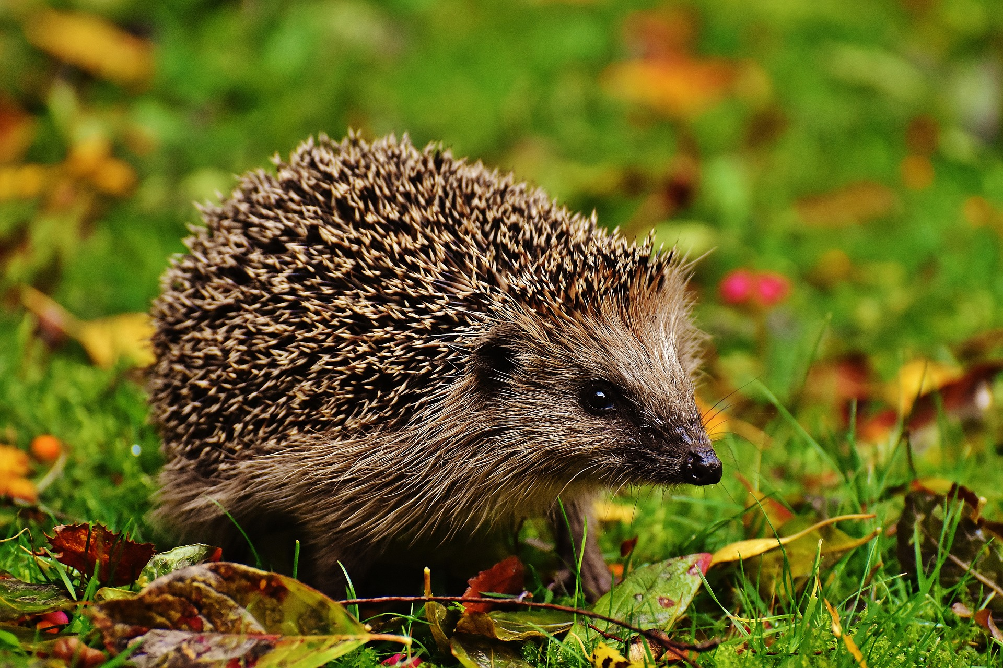
Encouraging natural predators - encouraging natural predators of any specific pest into the area, will help to control the pest in question. Ladybirds, lacewings, hoverflies, frogs, hedgehogs and birds are all great at limiting numbers of pests such as aphids and slugs.
Companion planting – by planting close together with species that attract predatory insects or disguise vulnerable plants, the impact on crop species can be reduced as pests are less likely to find them. The following plants protect food crops by deterring butterflies, moths, flies and beetles from laying their eggs:
- Rosemary, lavender and crow garlic
- Mint, goldenrod and amaranth
- Borage, dill and valerian
- Clover, sunflower and elderberry
- Coneflower
Hand picking – although time-consuming and intensive, removing areas of infestation by hand may be beneficial to the rest of the plot.
Many of the species targeted by chemical control, such as slugs and caterpillars, are fundamental parts of the food chain for many well-loved garden visitors such as our garden birds and hedgehogs.

How to create a pollinator-friendly site: step-by-step guides

Wildlife lawns
Difficulty: easy Maintenance: low Suitable: all sites with lawns
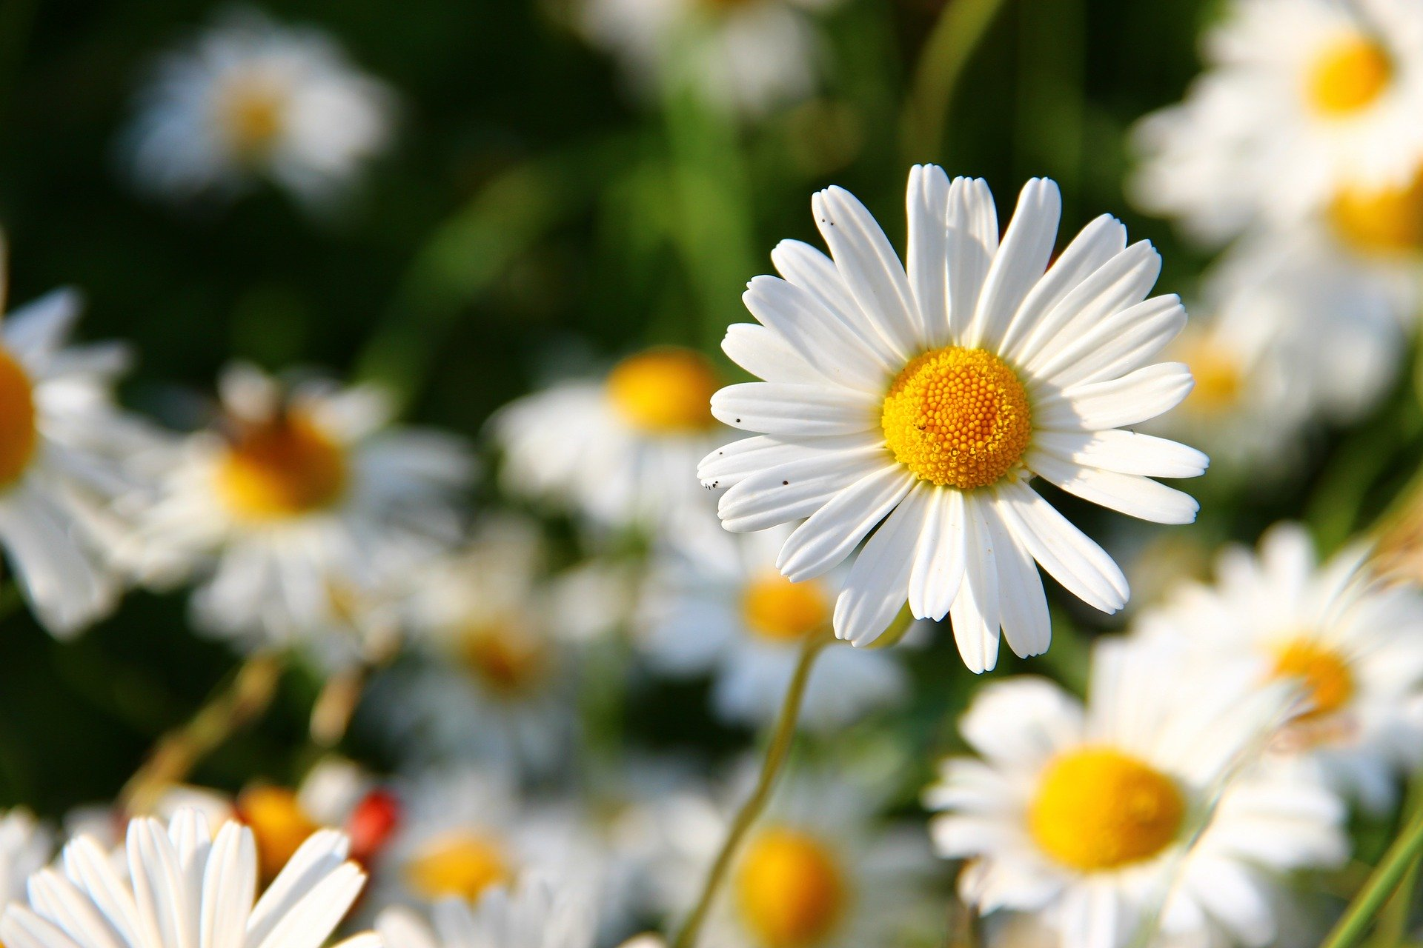
Dandelions, daisies, buttercups and clovers all provide excellent resources for pollinators. By simply mowing your lawn less over the spring and summer, or leaving corners and edges unmown, you can help provide valuable pollen and nectar for pollinators. In many ways, this is more beneficial then sowing a wild flower meadow as this utilises the natural ground flora present at your site and avoids the introduction of seed mixes that are not of local provenance (i.e. contain plants that would not naturally be found where they will be planted).

Log piles and stumperies
Difficulty: easy Maintenance: low Suitable for: all site sizes
You’ll need: sections of trunk or branches and a spade.
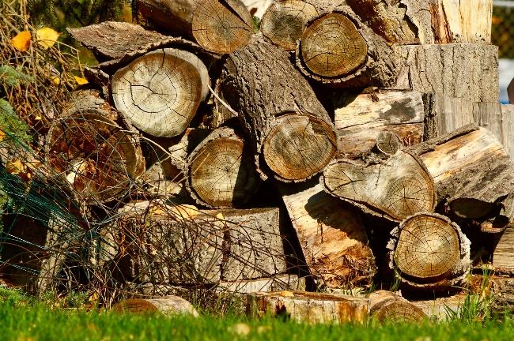
Did you know that nearly two thousand sorts of British invertebrates require dead wood, and use it in many ways?
To build a log pile, simply pile a few logs in an undisturbed area of your site and leave them alone. To encourage a greater diversity of invertebrates, try creating a few log piles in different areas around your site (e.g. sunny, shady, wet and dry). Stumperies are created by digging a hole in the ground and ‘planting’ the logs vertically so that half the log is in the hole. The gaps around the edges then need to be refilled with soil. This is particularly good for stag beetles!

Spring-flowering bulbs
Difficulty: Easy Maintenance: low Suitable for: all site sizes
Spring-flowering bulbs are a great way to make sure that there is nectar available when the first pollinators of the season emerge and look beautiful. Plant in the autumn for a fantastic springtime display. Many bulbs will flower year after year.
You’ll need: a spade, bulb-planter or trowel and spring flowering bulbs (see examples below). Optional: plant pots with drainage holes and compost.
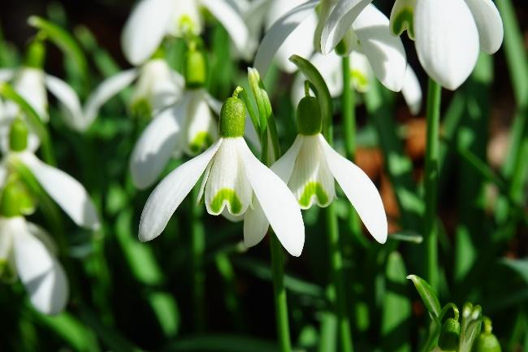
Step-by step guide:
- Choose a warm, sunny site with good drainage (or half-shade for snowdrops and wild daffodils)
- Dig a hole in a border or plant pot to a depth of 2-3 times the height of the bulbs.
- Place bulbs with their roots facing down and spaced twice their own width apart.
- Replace the soil with a spade or rake and avoid stepping on the soil.
- Water after planting, unless ground is moist.
Spring-flowering bulbs for pollinators:
Bluebell (Hyacinthoides non-scripta) - UK native
Snake's head fritillary (Fritillaria meleagris) - UK native
Lily of the valley (Convallaria majalis) - UK native
Chives (Allium schoenoprasum) – UK non-native
Crocus (Crocus species) - UK non-native
Common snowdrop (Galanthus nivalis) - UK non-native

Shrubs
Difficulty: easy Maintenance: low Suitable for: all site sizes
You’ll need: spade, pollinator friendly shrubs (see examples below).
Shrubs are woody plants, some of which can provide excellent foraging for pollinators and help fill out the borders in your site and leave some structure in your garden over the winter months.
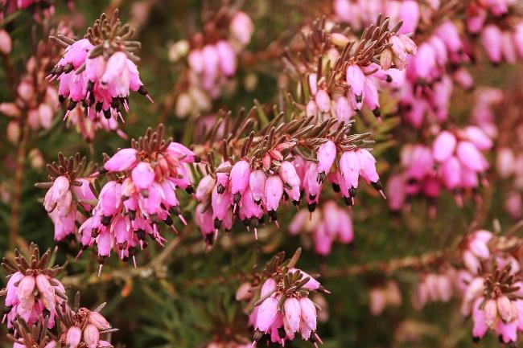
Step-by step guide:
- Find an area in a border with full or partial sun and well-drained soil
- Buy established shrubs (see examples below)
- Plant directly into borders by digging a hole slightly deeper than the plant pot
- Remove the shrub from the pot and place into the hole
- Backfill the gaps with soil and firm in well
Maintenance: Water regularly until established and in dry weather.
Flowering shrubs for pollinators:
Heather (Calluna vulgaris) - UK native
Bell heather (Erica cinereal) - UK native
Guelder rose (Viburnum opulus) - UK native
Common lavender (Lavandula angustifolia) - UK non-native
Rosemary (Rosmarinus officinalis) - UK non-native
Musk willow (Salix aegyptiaca) - UK non-native

Hardy annual flowering plants
Difficulty: easy Maintenance: medium Suitable for: all site sizes
You’ll need: trowel, rake, hardy annual seeds or potted plants (see examples below).
These plants only live for one year; however, they provide excellent floral resources for pollinators in the spring and summer. They will grow best in poor soil, where they have reduced competition from vigorous plants, like grass, nettles, dock and bramble, which love rich soil.
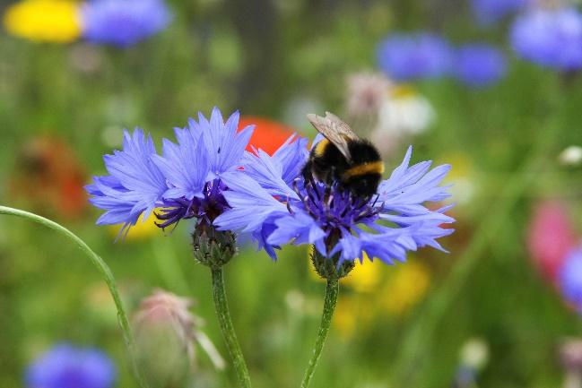
Step-by step guide:
- In mid-spring, find a border or pot which experiences full sun and has well-drained soil
- Remove weeds from soil using a trowel and rake soil until crumbly
- Scatter the seed (roughly 4g per square metre)
- Lightly rake in the other direction to cover the seeds
- Water immediately after sowing and during germination
Maintenance: water regularly. To avoid the birds from eating the seed you may want to cover your seeds with a fine net or criss-crossed strings raised off the ground by pegs.
Hardy annual flowering plants for pollinators:
Cornflower (Centaurea cyanus) - UK non-native
Corn chamomile (Anthemis arvensis) – UK non-native
Field forget-me-not (Myosotis arvensis) – UK non-native
Corn cockle (Agrostemma githago) – UK non-native
Common poppy (Papaver rhoeas) – UK non-native
Borage (Borago officinalis) - UK non-native
California poppy (Eschscholzia californica) - UK non-native
Poached egg flower (Limnanthes douglasii) - UK non-native
Love-in-a-mist (Nigella damascene) - UK non-native
Fiddleneck (Phacelia tanacetifolia) - UK non-native
Cosmos (Cosmos species) – UK non-native
Sunflower (Helianthus species) – UK non-native
Corn Marigold (Glebionis segetum) – UK non-native
Pot Marigold (Calendula officinalis) – UK non-native

Biennial flowering plants
Difficulty: easy Maintenance: medium Suitable for: all site sizes
You’ll need: trowel, rake, seeds or potted plants
These plants usually flower and die the year after they have been sown, however they can provide excellent floral resources for pollinators in the spring and summer. Most biennials need to be sown in the early summer to grow the following year.
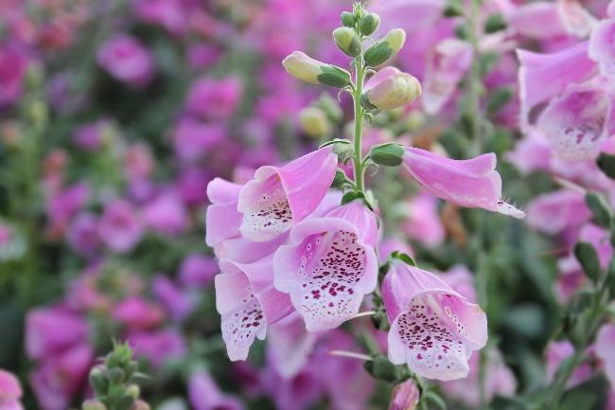
Step-by step guide (if buying pre-potted plants jump to Step 4):
- In early summer, dig and rake the soil to a fine tilth
- Sow the seeds into shallow drills (shallow long grooves), cover lightly and water regularly
- If seedlings start to crowd each other once growing, you can move them to a new row
- In the autumn, find a border or pot which experiences full sun or is partially shaded and has well-drained soil
- Remove weeds from soil using a trowel and rake soil until crumbly
- Replant the plants from the seedbed into the border or pot with a trowel (spacing dependent on species)
- Firm soil around the plants and water in
Maintenance: water regularly, remove weeds and add stake if plant needs stability in summer.
Biennial flowering plants for pollinators:
Wild angelica (Angelica sylvestris) - UK native
Viper's bugloss (Echium vulgare) - UK native
Foxglove (Digitalis purpurea) - UK native
Wallflower (Erysimum species) - UK non-native
Honesty (Lunaria annua) - UK non-native
Purple mullein (Verbascum phoeniceum) - UK non-native

Herbaceous perennial plants
Difficulty: easy Maintenance: medium Suitable for: all site sizes
You’ll need: herbaceous perennial plant seeds or potted plants (see examples below), rake and trowel.
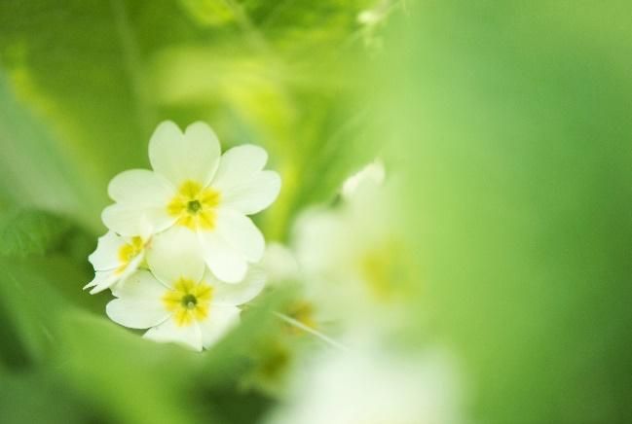
Perfect for attracting pollinators to your site borders, these flowering plants can live for many years. They may appear to die back over the winter as the roots survive in a dormant state before new growth in the next spring.
Step-by step guide (if buying pre-potted plants jump to Step 5):
- In late spring, fill a pot or seed tray with compost
- Sow the seeds into shallow drills (shallow long grooves) and water
- If seedlings start to crowd each other once growing, you can move them to a new row
- Leave seedlings to grow until the following autumn
- In the autumn, find a border or pot which experiences full sun or is partially shaded and has well-drained soil
- Remove weeds from soil using a trowel and rake soil until crumbly
- Replant the plants from the seedbed into the border or pot with a trowel (spacing dependent on species)
- Firm soil around the plants and water in
Maintenance: water regularly and add stake if the plant needs stability in summer. Once the plants have flowered, leave the stems and seed heads on over winter to provide valuable food and shelter for birds and invertebrates. From March onwards, you’ll need to use secateurs or shears to cut dead stems whilst avoiding cutting any new shoots.
Herbaceous perennial plants for pollinators:
Bugle (Ajuga reptans) - UK native
Sea pink (Armeria maritima thrift) - UK native
Clustered bellflower (Campanula glomerate) - UK native
Greater knapweed (Centaurea scabiosa) - UK native
Hemp agrimony (Eupatorium cannabinum) - UK native
Common fennel (Foeniculum vulgare) - UK native
Meadow cranesbill (Geranium pratense) - UK native
Water avens (Geum rivale) - UK native
Orpine (Hydrotelephium telephium) - UK native
Ox-eye daisy (Leucanthemum vulgare) - UK native
Ragged robin (Lychnis flos-cuculi) - UK native
Purple loosestrife (Lythrum salicaria) - UK native
Musk mallow (Malva moschata) - UK native
Wild marjoram (Origanum vulgare) - UK native
Common bistort (Persicaria bistorta) - UK native
Primrose (Primula vulgaris) - UK native
Small scabious (Scabiosa columbaria) - UK native
Aquilegia (Aquilegia vulgaris) – UK native
Red campion (Silene dioica)– UK native
Field scabious (Knautia arvensis) – UK Native
Betony (Stachys officinalis) – UK native
Helenium (Helenium species) – UK non-native
Lungwort (Pulmonaria officinalis) – UK non-native
Catmint (Nepeta species) – UK non-native
Cranesbill (Geranium species) – UK non-native
Globe thistle (Echinops species) – UK non-native
Inula (Inula species) – UK non-native
Astrantia (Astrantia species) – UK non-native
Michaelmas daisy (Aster species) – UK non-native
Salvia (Salvia species) – UK non-native
Verbena (Verbena species) – UK non-native
Lamb’s ear (Stachys byzantine) – UK non-native

Flowering trees
Difficulty: medium Maintenance: medium Suitable for: all sites
You’ll need: a flowering tree (see examples below), a spade, a stake, a hammer and a tree tie. (Optional: plant pot if not planting directly into the ground).
Trees are simply brilliant for wildlife and many blossoming trees are particularly beneficial to pollinators. If the ground isn’t frozen or waterlogged, the easiest time to plant a tree is between October and March, however most can be planted at any time of year.
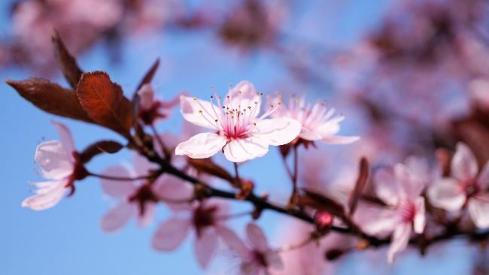
Step-by step guide:
- Choose a place for your tree considering how big it will grow and the shade it will create.
- Dig a hole twice as wide as the roots of your tree and to the same depth that it has previously been growing.
- Place your tree in the hole and pull the soil back over the roots gently and firmly. If planting a bare-rooted tree, keep its roots wrapped in plastic until the last moment to avoid the roots drying out.
- To keep your tree upright, you may choose to hammer a wooden stake at an angle (leaning into the wind) next to the tree and use a rubber tree-tie to attach the tree to the stake (usually one third of way up trunk).
- Water your tree and lay mulch (e.g. sheep fleece or gravel) in a circle around the trunk to minimise weed growth.
Maintenance: water your tree regularly for the first year and remove the supporting stake after 2-4 years once the tree can support itself. Check the tie each year and loosen if necessary, to make sure it doesn’t cut into the bark as the tree grows. Cut out any dead or diseased wood each year to keep your tree healthy.
Flowering trees for pollinators:
Common hawthorn (Crataegus monogyna) - UK native
Common holly (Ilex aquifolium) - UK native
Cherry (Prunus avium) - UK native
Common whitebeam (Sorbus aria) - UK native
Rowan (Sorbus aucuparia) - UK native

Bee hotel
Difficulty: medium Maintenance: medium Suitable for: all site types
You’ll need: offcuts of planks of wood, saw, nails, drill, bamboo canes, hollow plant stems and/or reeds. Alternatively, you can buy pre-made bee hotels which are ready to put up in your site or you can simply tie together bundles of cut bamboo canes to hang.
Solitary bee species which like to nest above ground level, including mason bees and leafcutter bees, lay their eggs in tunnels, such as in dead wood or hollow plant stems in spring and summer. You’ll be able to see if any of the holes have been used because the holes will be blocked with plugs of mud or leaves.
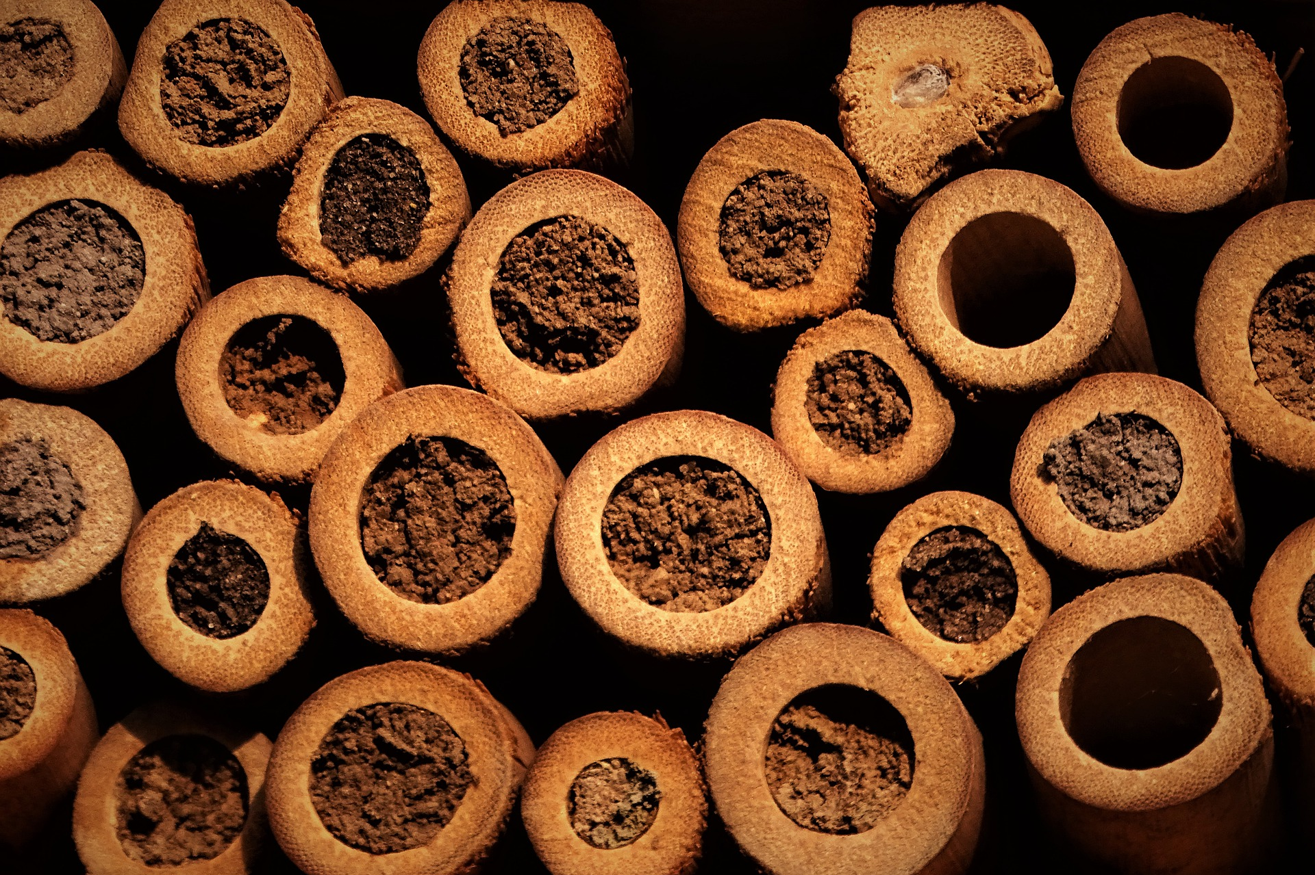
Step-by step guide:
- Measure, saw and nail wood together to build an open box (15cm deep). If preferred, you can also create multiple compartments and different shapes.
- Cut bamboo, hollow plant stems and/or reeds, to the depth of the box and wedge in (end-on) until they are stuck. Alternatively, you can create holes by drilling deep holes of varying sizes (2-8mm diameter) into a solid block of wood.
- Fix the box at waist or chest height to a fence or wall in a sunny, sheltered, south facing position.
- Ensure that the tunnels do not move, but otherwise leave your bee hotel for the bees.
- Protect bee hotels from rotting in winter by moving to an unheated dry space (e.g. garage or shed) and returning them to the outdoors in early spring.
Maintenance: After a few years, it’s best to create a new bee hotel and put it up in a different location.

Bug hotel
Difficulty: medium Maintenance: low Suitable for: all site types
What you’ll need: Old untreated wooden pallets and bricks and any of the following - strips of wood, straw, moss, dry leaves, woodchips, old terracotta pots, old roofing tiles, old logs, bark, pine cones, sand, soil, bamboo canes, planks of wood (avoid plastic).
Create a multi-storey hotel that's full of all sorts of natural materials, providing hidey-holes for creatures galore.
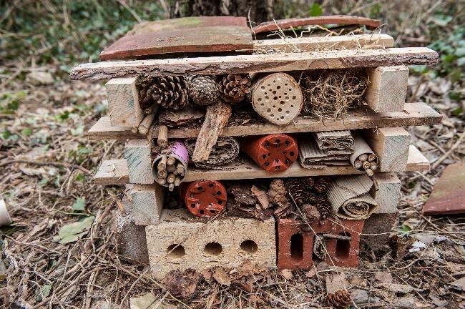
Step-by step guide:
- Choose a level site with firm ground away from vegetable beds (as this hotel should appeal to snails and slugs).
- Build strong framework no more than a metre high using pallets stacked on top of base of bricks (leave some gaps between bricks)
- Fill the gaps of the pallets with the other materials. The idea is to provide all sorts of different nooks and crannies, crevices, tunnels and cosy beds.
- Add a roof to keep the hotel relatively dry using old roof tiles or some old planks.
Top tip: to help engage children create a name and a sign for your bug hotel.

Climbing plants
Difficulty: medium Maintenance: medium Suitable for: bare walls or fences
You’ll need: spade or site fork, wildlife-friendly climbing plant (see examples below), compost, watering can. (Optional: a large pot, trellis or taut wires, toolkit, screws).
Growing climbing plants is a brilliant and beautiful way of bringing life to your dead vertical surfaces, like a wall, fence or pergola. There are a range of climbers that you can plant at any time of year and that are fantastic for pollinators.
Step-by step guide:
- Find a bare, vertical surface.
- Choose your climbing plant and check individual plants for preferred amount of sun; most will prefer a sunny south-facing wall or fence.
- Build trellis or climbing structure using wire if necessary.
- Plant climber one foot from wall/fence, leaning towards wall/fence and mix in compost and water regularly.
Maintenance: keep well-watered in dry weather and prune as recommended for each plant.
Climbing plants for pollinators:
Common ivy (Hedera helix) - UK native (aerial roots can damage brickwork)
Common honeysuckle (Lonicera periclymenum) - UK native
Dog rose (Rosa canina) – UK native
Common jasmine (Jasminum officinale) – UK non-native

Herb garden
Difficulty: medium Maintenance: high Suitable for: all site sizes
You’ll need: relatively deep plant pots with drainage holes in base, compost, gravel, pre-potted herbs (see examples below).
Flowering herbs can provide both nectar for pollinators and fresh seasoning for you! Here we describe how to create a herb site in pots, however established herbs can also be planted directly into well-drained soil.
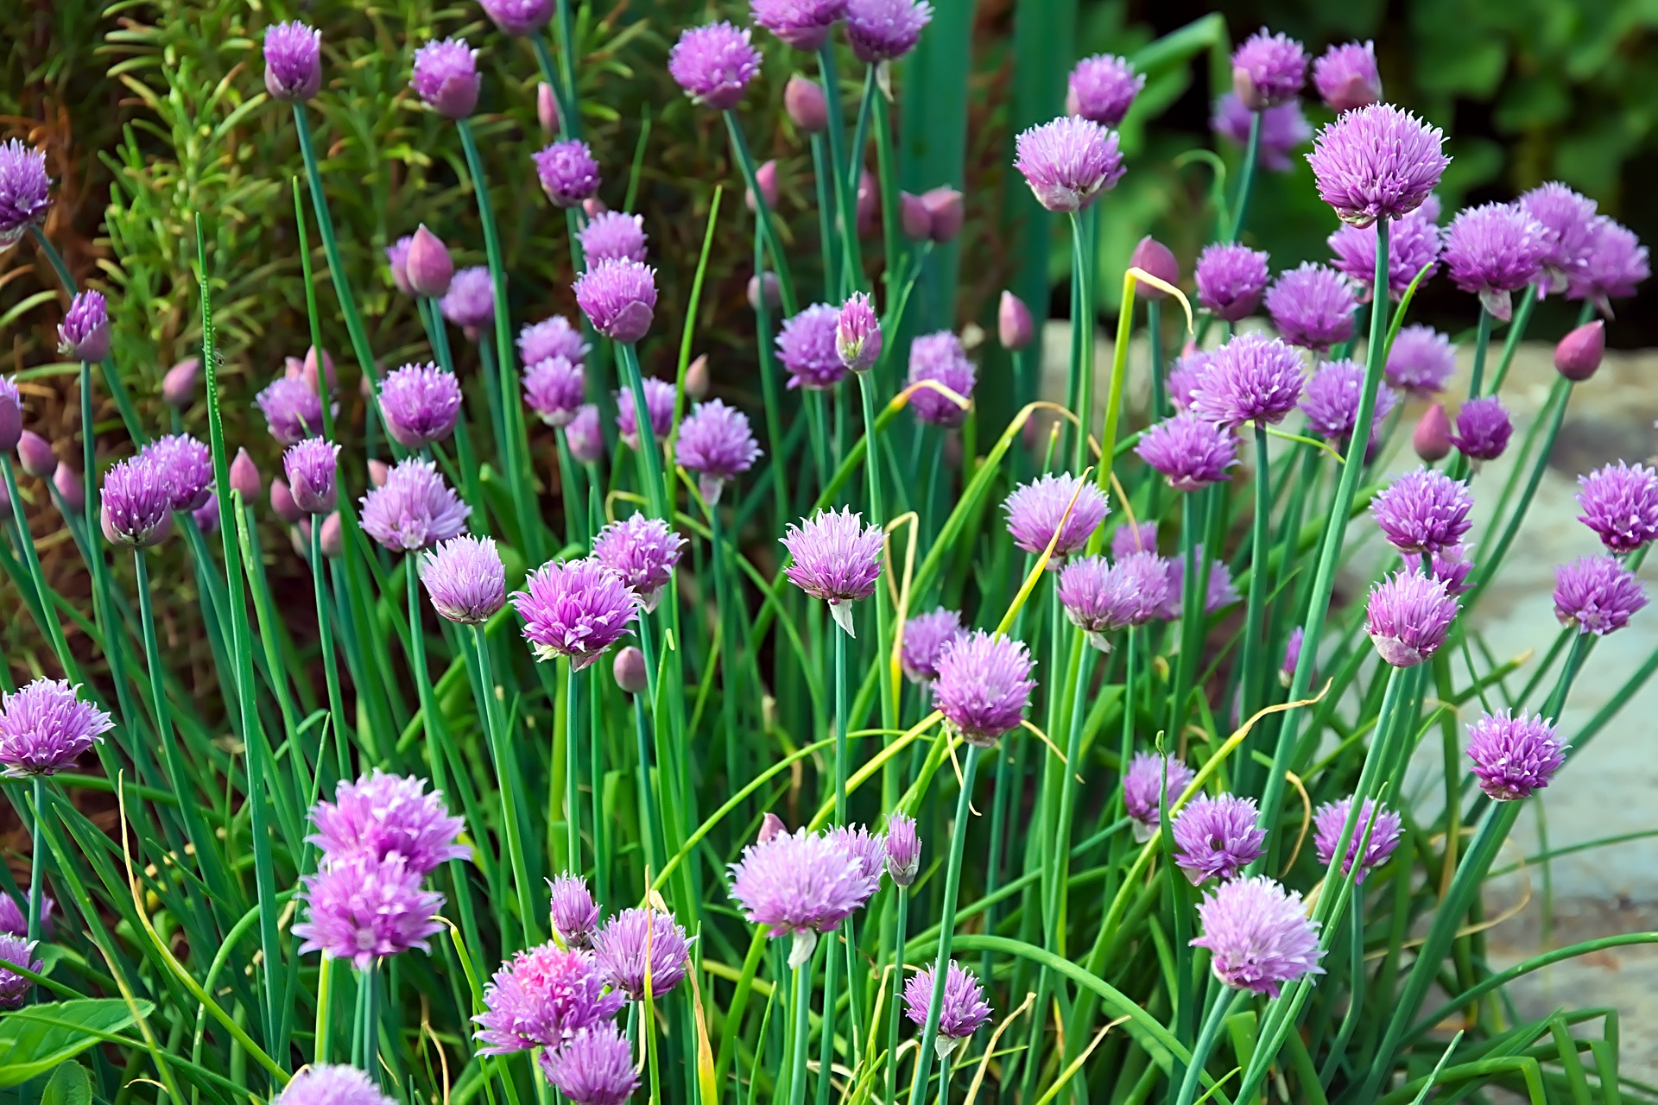
Step-by step guide:
- Find a sunny and sheltered location to place pots
- Mix compost with gravel to improve drainage and put into pots
- Purchase pre-potted herbs in the spring
- Plant pre-potted plants into prepared pots and water regularly
Maintenance: Water dry weather and trim herbs regularly. The best time to buy pre-potted herbs from site centres is in the late spring.
Herbs, bulbs and shrubs for pollinators:
Chives (Allium schoenoprasum) - UK non-native - Bulb
Common sage (Salvia officinalis) - UK non-native - Herbaceous perennial
Fennel (Foeniculum vulgare) - UK non-native - Biennial
Marjoram (Origanum majorana) – UK native - Shrub
Mint (Mentha spicata) - UK non-native - Herbaceous perennial
Rosemary (Rosmarinus officinalis) - UK non-native - Shrub
Thyme (Thymus species) - UK non-native– Shrub

Wildflower meadow
Difficulty: medium Maintenance: high Suitable for: medium and large sites
You’ll need: Wild meadow seed, spade, dry silver sand.
Wildflower meadows mainly comprise of wild grasses, which are maintained by mowing. Wildflower meadows should only be sown where a site is very species-poor, as the best way to create a wildflower meadow is to simply leave areas without mowing (see our ‘Wildlife lawns’ section). However, autumn is generally the best time to create and sow a wildflower meadow. Wildflower meadows grow best on infertile soil and will evolve year by year. Note: if your area is prone to high rainfall/flooding or has clay soil which can become waterlogged in the winter, then a spring sow is recommended.
Step-by step guide:
- If the soil is too fertile, remove top 3-6 inches of topsoil using a turf cutter or spade to reduce fertility.
- Dig the soil and remove any weeds to create a fine soil. (Alternatively, you can cut the existing vegetation as low as possible, rake off any cuttings and use rakes to create 40-50% bare ground.)
- Choose a native wildflower meadow seed mix of UK provenance which should contain some of the following: birds-foot trefoil, common sorrel, cowslip, field scabious, hoary plantain, knapweed, lady’s bedstraw, meadow buttercup, ox-eye daisy, red clover, ribwort plantain, wild carrot, yarrow, yellow rattle, bents, fescues, and crested dogstail.
- In autumn, scatter 5 grams of seed per square metre evenly across the ground.
- Walk over soil so that seeds are in contact with soil. The area may need netting to protect the seeds from being eaten by birds.
Maintenance: keep well-watered in the first year. In the first year during the midsummer, mow and remove all cut material. For the following summers, avoid mowing from April to September to ensure pollen and nectar resources are available throughout the period when pollinators are most active. During autumn and early spring, mow a couple of times and ensure the cuttings are removed to avoid leaving behind a damaging mulch of decomposing cut grass.

Bee bank
Difficulty: hard Maintenance: medium Suitable for: medium and large sites
You’ll need: spade, aggregate/stones and builder’s sand.
A bee bank provides warm, sheltered patches of bare ground where solitary mining bees can nest.
Step-by step guide:
- Choose a sunny, south or south-east facing and sheltered spot of any size.
- Remove 15cm turf from the area, including up to one metre extra around the edge.
- Pile the removed turf upside-down in the desired spot for the bee bank and using blocks of turf, begin to build the shape you want your bank (we recommend a crescent moon shape as this maximises surface area and creates different angles and aspects).
- Use aggregate/stones to cover the bank – this will suppress grass growth and prevent it growing up through the bee bank.
- Finally cap with builder’s sand. This must be at least 30cm deep for the bees to burrow into. Compact the sand using the back of your spade.
- Use sand to cover the border around the bee bank to suppress additional plant growth and provide additional habitat for mining bees to use.
Maintenance: Annual weeding to maintain bare ground and ensure that vegetation does not take over.

Pond
Difficulty: hard Maintenance: low Suitable for: all site types
You’ll need: spade, sand, underlay, butyl liner, play sand and/or fine gravel and a range of aquatic plants (such as native frogbit, hornwort, ivy-leaved crowfoot or water crowfoot) and marginal plants (e.g. yellow iris, bogbean, purple loosestrife). You can also create ponds using old sinks, troughs or site planters, or pre-formed ponds can be bought from garden centres. Ideally, these would have shelved sides to allow animals to exit the pond.
Making a pond is one of the best things you can do for wildlife. It will attract aquatic invertebrates, breeding dragonflies and many others to its margins.
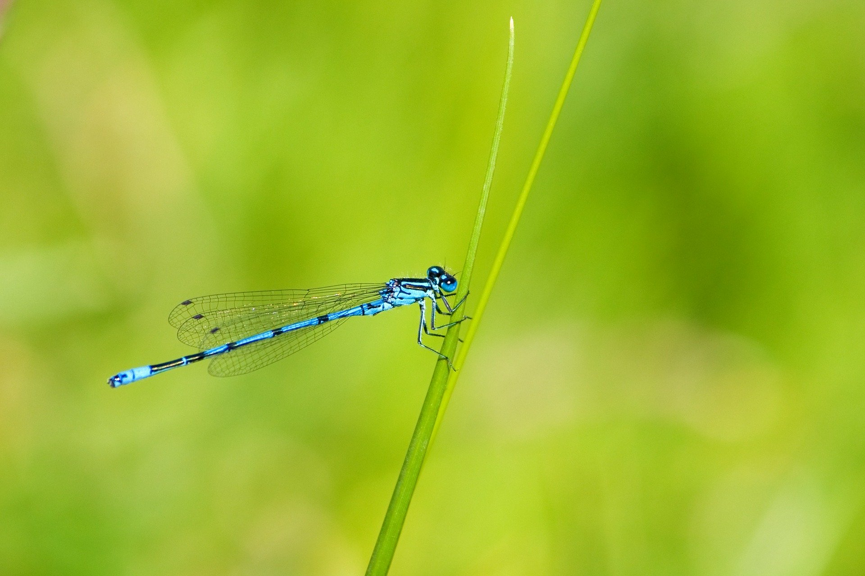
Step-by step guide:
- Find a flat place that is safe to put a pond (e.g. away from unsupervised children with enough space to walk around) and that is less than 25% shaded.
- Mark out the pond area.
- Remove turf and dig out a hollow with shelving sides. Ensure the margins of the pond are level.
- Remove any stones and then line with first sand, then underlay, and finally a butyl liner. (Optional: cover liner with more underlay to protect the liner)
- Add a bed of children’s play sand and/or washed fine gravel for planting.
- Replace turfs along the edges for a natural look, but keep the soil above the water level.
- Fill pond from rainwater, either naturally or with a water butt.
- Once water has settled add plants either directly into the bed or in their pots.
Your new pond may experience an ‘algal bloom’ at first but should clear naturally.

